Asfordby Hill School

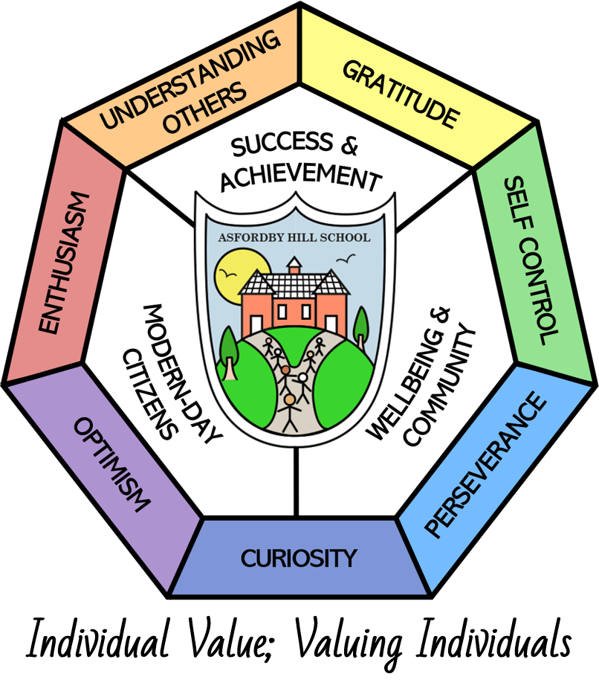

Positive Handling POLICY

This Policy Links With:
Health and safety
SEND
Equality
Behaviour
Recommended: | Yes
Statutory:

Date Reviewed: | February 2024
Date of Next Review: | February 2026
Committee Responsible for Review: | QEHS
Date Governors agreed: | 13.2.24

Context.

The Education and Inspections Act 2006 establishes the power of teachers and other staff to use reasonable force to prevent a pupil from doing or continuing to do any of the following;
- Self injuring
- Causing injury to others
- Committing a criminal offence
- Engaging in any behaviour prejudicial to maintaining good order and discipline.

Asfordby Hill Primary School recognises that there is a need, reflected by this act, to intervene when there is an obvious risk of safety to its’ pupils, staff and property.

This Positive Handling Policy should be considered alongside other relevant policies in the school, specifically those involving behaviour, bullying, child protection and health and safety.

Purpose of policy.

Good personal and professional relationships between staff and pupils are vital to ensure good order in our school.

We recognise that the vast majority of our pupils respond positively to the Behaviour Policy that operates in school. This ensures the well being and safety of all pupils and staff in our setting.

It is also recognised that in exceptional circumstances, staff may need to take action in situations where extreme challenging behaviour is compromising the safety and well being of the pupil themselves and/or other staff and pupils in school.

Asfordby Hill acknowledges that physical handling techniques are only part of a whole school approach to behaviour management and should be used only as a last resort in line with the DFES advice.

There must also be recognition of the distinction between appropriate physical contact used in everyday situations to support, encourage, guide or comfort and the use of physical intervention to disengage pupils whose behaviour is posing a threat to themselves or others.

Implications of the policy.

Types of incident where the use of physical handling techniques may be necessary are:
- Action where a pupil places themselves at risk.
- Action where a pupil places other pupils or staff at risk.
- Action leading to serious damage to property.
- Action where a pupil is compromising good order and discipline.

Staff have a responsibility to seek alternative strategies wherever possible in order to prevent the need for physical intervention. Creating a calm learning environment that minimises the risk of incidents that may require using force and using social and emotional aspects of learning approaches to teach pupils how to manage conflict and feelings of strong emotion are two examples of strategies used at Asfordby Hill Primary School.

As endorsed in the school’s Behaviour Policy, staff utilise consistent positive strategies to encourage acceptable behaviour and good order. Our approach includes an understanding of personal space, body language and a personal safety curriculum as well as safe physical handling techniques.
Every effort will be made to resolve conflicts positively and without harm to pupils, staff or property.

“Reasonable force” will only be used as a last resort when all other behaviour management strategies have failed or when pupils, staff or property are at risk. See:

(“Use of Reasonable Force – Advice for Headteachers, staff and Governing Bodies.” DFE July 2013)

Strategies for dealing with challenging behaviour.

Before any physical intervention:

- Try to de-escalate the situation by explaining that you understand how they feel and want to help
- Try to distract the pupil
- Provide choices so that the pupil can see a way out
- Remind pupils of strategies they can employ/have practised
- Suggest a safe place to go and calm down

Where this doesn’t work and unacceptable behaviour threatens good order and there is a risk of harm, some or all of the following approaches should then be taken according to the circumstances.

- Ask the pupil to behave appropriately, clearly stating the desired behaviour.
- Tell the pupil that physical intervention will take place if inappropriate behaviour continues.
- Intervene in a measured way using physical intervention – reasonable force used to prevent a child harming him/herself, others or property.

All staff who undertake the Team Teach training are authorised by the HT, that whilst they have control or charge of pupils, they automatically have the statutory power to use force as part of the risk assessment and positive handling plan (PHP). Any child who has potential needs identified due to the use of any incidence of positive handling, must have a PHP in place. Risk assessments are completed against each child when physical restraint may need to be used in the context of identified target behaviours.

Use of Positive Handling Techniques.

The use of restraint requires skill, judgement and knowledge of non-harmful methods of control. Reasonable force would include those methods taught and practised by Team Teach training.

The degree of physical intervention employed must be in proportion to the circumstances of the incident and the seriousness of the behaviour or the consequences it is intended to prevent.

Physical Control

This may be used to divert a pupil from a destructive or disruptive action, for example guiding or leading a pupil by the arm or shoulder with little or no force. The important factor within these situations is the compliance of the child as a result of the intervention.

Physical Intervention

This will involve the use of reasonable force when there is immediate risk to pupils, staff or property. The methods used will be the approved techniques accredited by Team Teach. As previously stated, it is important to note that the use of “reasonable force” should be seen as a last resort.

Health and Safety

When using reasonable force/physical intervention, the pupil’s health and safety must always be considered.
Physical handling should involve the minimum amount of force necessary to resolve the situation.

Recording.

In the event of an incident where physical restraint is required, it will be recorded in the’ Bound and Numbered’ incident book within 24 hours and entered onto Cura. If possible, all staff and children involved will undertake a de-brief meeting with the Head teacher. The de-brief will include discussing what led up to the incident, the incident itself, what will happen next and lessons learned from the incident. This gives an opportunity to re-build relationships so that all parties are able to re-focus on the learning and the reason why we are in school. The parents/carers should be informed of the incident as soon as possible.
A Health and Safety /Incident Form will be completed and returned to the Authority.
The Head teacher will ensure that each incident is reviewed and investigated further as required. If further action is required in relation to a member of staff or pupil, this will be pursued through the appropriate procedure.

Complaints.

The availability of a clear policy about reasonable force and early involvement of parents should reduce the likelihood of complaints but may not eliminate them.
Any complaints about staff will be investigated through the School’s Complaints Policy. If necessary the complaint will be dealt with by the Staff Disciplinary Procedures and/or Child Protection Procedures.

Monitoring Incidents
Whenever a member of staff has occasion to use reasonable force, this will always be recorded and documented following agreed procedures. Monitoring of incidents will help to ensure that staff are following the correct procedures and will alert the Head teacher to the needs of pupils whose behaviour may require the use of reasonable force.

Regular monitoring of incidents will take place and the results used to inform planning to meet the needs of individual pupils and the school.

Further information

DCSF guidance.
Physical interventions can be defined in two broad categories:
• Non-restrictive (associated with a lower level of risk);
• Restrictive (where a higher level of risk is present).

Examples from these two categories are provided in DfES Circular LEA/0242/2002 as follows:
Non-Restrictive - Manual guidance to assist a person walking. Use of a protective helmet to prevent self-injury. Removal of the cause of distress, e.g. adjusting temperatures, light or background noise.
Restrictive- Holding a person’s hands to prevent them hitting someone. Use of arm cuffs or splints to prevent self-injury. Forcible seclusion or the use of locked doors.

Restrictive physical interventions can be employed to achieve a number of different outcomes:

• to break away or disengage from dangerous or harmful physical contact initiated by a service user;
• to separate the person from a ‘trigger’, for example, removing one pupil who responds to another with physical aggression;
• to protect a child or service user from a dangerous situation – for example, the hazards of a busy road.
DfEE Circular 10/98 gives examples of situations where reasonable force might be necessary to control or restrain pupils. In general, if a person is at immediate risk of injury from a pupil’s action, or serious damage is about to occur, then it might be necessary to intervene. Care should be taken not to use excessive force and to guard against the possibility of injury or asphyxiation. Adults need to be sensitive to issues of gender and to their own strength and body weight. DfEE Circular 10/98 (paragraphs 21-27) discusses these issues in more detail, and the attention of staff is drawn to the list of actions in paragraphs 23 and 24 of the Circular which would normally be considered unjustifiable, including:

• holding a pupil around the neck, or by the collar, or in any other way that might restrict the pupil’s ability to breathe;
• slapping, punching or kicking a pupil;
• twisting or forcing limbs against a joint;
• tripping up a pupil;
• holding or pulling a pupil by the hair or ear;
• holding a pupil face down on the ground.

Higher levels of risk are associated with:

• the use of clothing or belts to restrict movement;
• holding someone who is lying on the floor or forcing them onto the floor;
• any procedure which restricts breathing or impedes the airways;
• seclusion, where a child is forced to spend time alone and unsupervised in a room against their will;
• extending or flexing the joints or putting pressure on the joints;
• pressure on the neck, chest, abdomen or groin areas.

[Note: For consideration: In services or establishments where the use of physical restraint is likely to be required on more than an occasional basis detailed practice guideline should be drawn up for staff and appropriate training provided. In the formulation and implementation of such guidelines or policies, the approval of the governing body is needed and good communication and consultation with parents is advised. Specialist settings, such as special schools or units are advised to consider Circular LEA/0242/2002 in its entirety.

DfES Guidance
The relevant DfES guidance is:
• DfES Circular LEA/0264/2003 (September 2003): Guidance on the Use of Restrictive Physical Interventions for Pupils with Severe Behavioural Difficulties: this contains model policies for LEAs and special schools, although this could be adapted for other settings, and advice on risk assessment
• DfES Circular LEA/0242/2002 (July 2002): Guidance on the use of restrictive physical interventions for staff working with children and adults who display extreme behaviour in association with learning disability and/or autistic spectrum disorders: this includes a DfES letter of April 2001 about positive handling strategies for pupils with severe behavioural difficulties
• DfEE Circular 10/98 (July 1998): Section 550A of the Education Act 1996: The Use of Force to Control or Restrain Pupils: this clarified new legislation.
Relevant DfES websites: www.dfes.gov.uk/sen www.teachernet.gov

