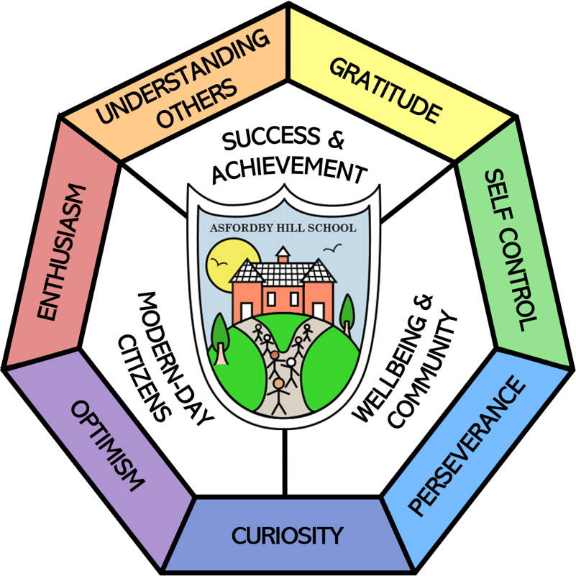

Asfordby Hill Primary School

SEND Information Report
2025 – 2026

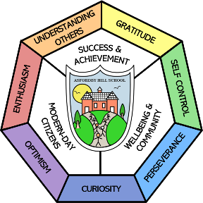  Our School | Our School Vision  At Asfordby Hill Primary the well-being and development of each child underpins all that we do. Our aim is to develop children into confident and resilient learners, for them to develop a love of learning and to encourage them to explore opportunities to step outside of their comfort zone whilst not neglecting the need to develop wider life skills that they can use to underpin their future development.  September 2024 Information  Age Range of Students: 4-11  ​Date of last inspection: 6th and 7th January 2026  ​Outcome of inspection: Strong  Asfordby Hill currently has 191 children on role (October 2024)  There are currently 30 children on SEND register with a range of needs from universal to specialist. (14.7% compared to last year 18.2% a decrease of 3.5%)  13 children (6.8%) that can be accommodated through quality first teaching (universal needs) and support planned by class teacher.  6 children (3.1%) have a diagnosis of need that requires targeted interventions through QFT and support planned by class teacher. (targeted need)  5 children (2.6%) have a significant and complex need that requires support over and above in class provision. (specialist need)  7 children that have an EHCP (3.7%) and 5 children have a SEND Support Provision Plan (2.6%) of which 1 children have SEN intervention funding.
  Meet our SENDCO |   Mrs Bailey  As of April 2026, the SENDCO is Mrs Bailey.  If you would like to contact Mrs Bailey, please call school on 01664 812244 or email admin@asfordbyhill.leics.sch.uk  Mrs Bailey is a qualified teacher and regularly attends courses. She has an accredited NASENCO award from Nottingham Trent University and the NPQH qualification.
  Special Educational Needs | At Asfordby Hill Primary School we support children with a variety of differing special educational needs and we pride ourselves on being a highly inclusive school with an ethos which encourages and celebrates diversity and difference.  SEND is categorised into the following areas in the SEN code of practise 2014:
   | Cognition and Learning
   | Communication and Interaction
   | Social, Emotional and Mental Health
   | Sensory and Physical
  Identifying and Assessing Need | At Asfordby Hill we work closely as a team and if staff have a concern about a child. They fill in an Initial Concerns form and discuss concerns with parents. A child will then be placed on the monitoring register and we begin to follow the Graduated Response approach of ‘Assess, Plan, Do and Review’.  After a period of 6 – 8 weeks we will decide if a child needs to be placed on the SEND register and invite parents in for a meeting, where we will share the targets your child is working on and the support they are receiving.  Some children will be monitored using specific SEND assessments, this allows the children who are working at below key stage standards to have small step targets set in lessons to allow them to achieve and begin to work independently.  Some children may require more support than is ordinarily available and we may ask outside agencies to support us in ensuring that we are offering the best support we can.  Staff can access the Ordinarily Available Guidance (January 2024) to help support children’s learning within the classroom. Ordinarily Available Provision - Leicestershire SEND  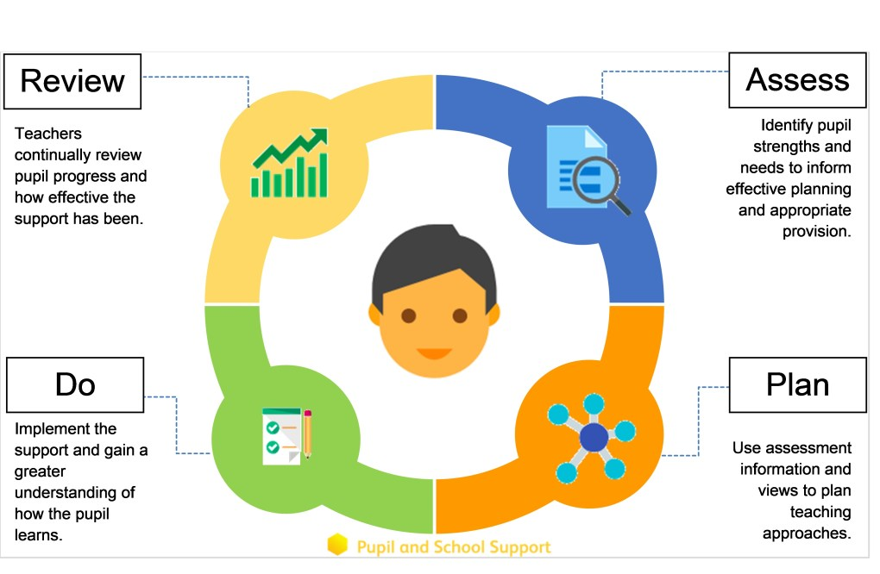
  Our approach to teaching children with SEND | We are an inclusive school. Wherever possible children are taught alongside their peers in flexible teaching groups.  Teachers adapt their high-quality teaching to cater for their pupils’ needs and plan individual timetables where necessary. When appropriate, staff are deployed to give children additional interventions in small groups outside the classroom, or to provide one-to-one support.  We use the EEF guidance ‘Five-a-day’ and embed the key principles into all our lessons.  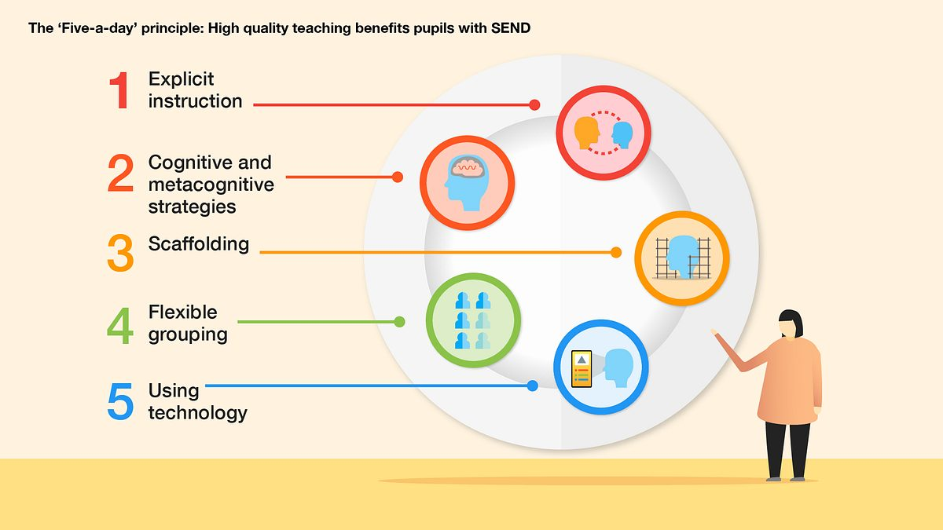  The method of identification and provision follows the recommended graduated response: ‘Assess, Plan, Do, Review.’  Quality First Teaching (QFT), for all pupils, considering individual learning styles and personal preferences.  QFT plus additional, time-limited intervention support programmes, either individually or in groups, are designed to accelerate learning and enable a pupil to catch-up to expected levels.  QFT plus increasing individualised programmes of intervention sometimes with recommendations from outside agencies (children working with SEN Support)  Examples of Intervention work may include but not limited to the following:  English booster groups, small intervention focus groups Beat Dyslexia, Toe by Toe, Fluency reading groups, pre teaching strategies, precision teaching  Maths booster groups, Springboard, Numicom, pre-teaching learning  Social skills groups- playtime games club, Lego therapy, Play and Stay, nurture group sessions, ECAT, social interaction and communication support  Emotion and Social groups- ELSA  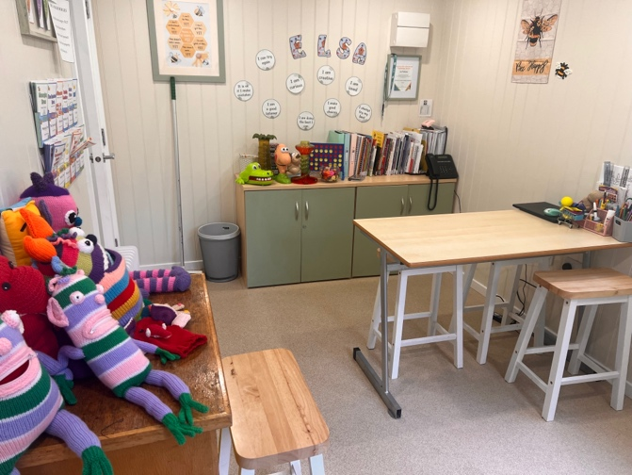
  Curriculum adaptations | We use a range of strategies across our lessons to ensure we offer an inclusive approach to learning and allow all children to access the classroom environment.  We also seek advice and equipment from outside agencies as and when the need arises.  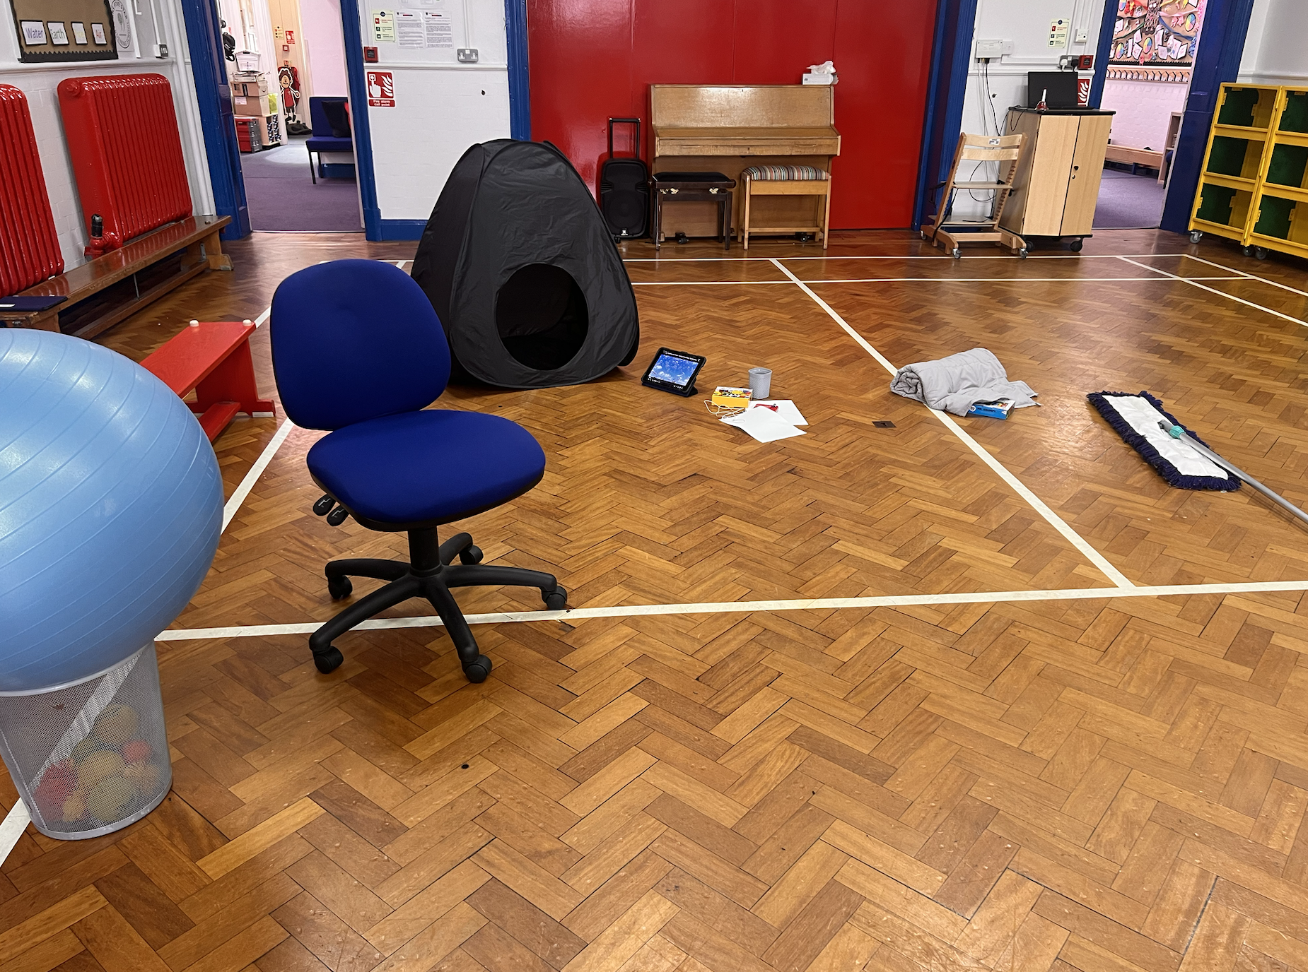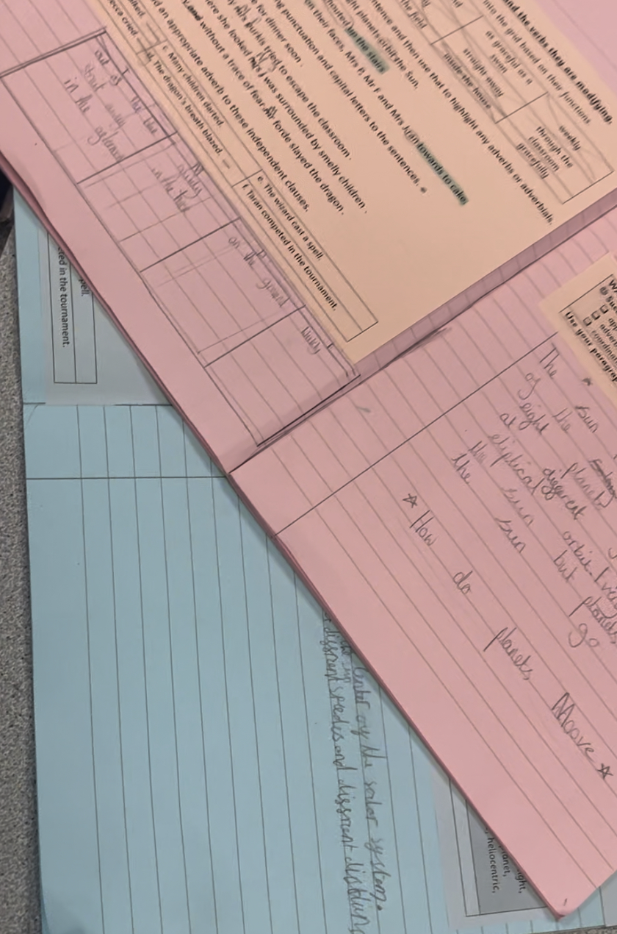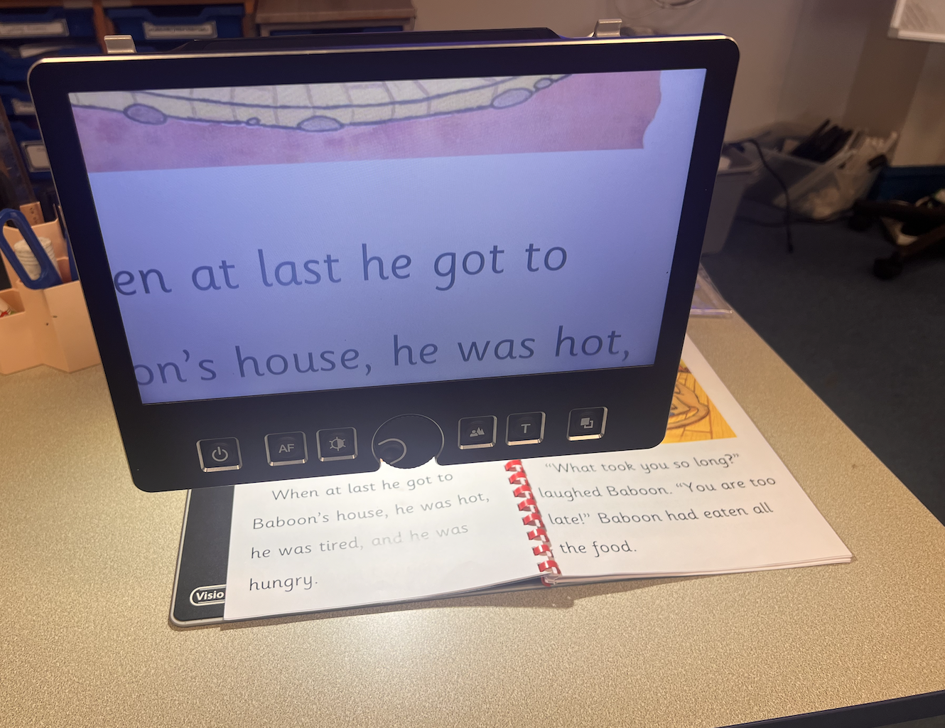
  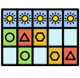 |  | 
  Visual timetables | Task boards | Peer mentoring
   |  | 
  Assistive technology | Talk partners | Peer marking
   |  | 
  Self-assessment | Word banks | Positive behaviour
   |  | 
  Ear defenders | Timers | Explicit instruction
  Parent Consultations | At Asfordby Hill Primary School we work closely with parents and carers and recognise that they have much to contribute to our support for children with SEND.  All parents have access to the school handbook and SEND Policy through the school website.  We hold monthly SEND clinics and Mrs Bailey is available at parents’ evenings to discuss any concerns.  Our SENDCo governor holds monthly coffee mornings where parents across Melton Mowbray can meet up and support each other in a safe environment with regards to ASD. From January 2025, termly coffee morning will be hosted by Mrs Bailey within school. During these sessions we will gather parent feedback on SEND provision at Asfordby Hill, direct to training courses and support groups and offer opportunities to meet up with outside agencies.  For children who have an Education, Health and Care Plan, SEN Support Provision Plan or require specialist support (over and above what is ordinarily available) we will invite you in for a further meeting once a year. These meeting are used to celebrate your child’s learning, looking at the progress they have made against the targets set, create new targets and discuss next steps. A copy will always be uploaded to the child’s Kinteract account.  During the year a parental questionnaire is sent out to gain views on the school and the SEND provision.
Child Consultations | Pupil’s views are very important; they have a right to be involved in decisions about their education and they are made aware of the support that surrounds them in school.  Children are fully involved and their views feed directly into all policies, procedures and daily teaching of children with SEND.  Children on any stage of the SEN register are involved when setting their targets and are informed about their progress on a regular basis. Pupils are invited to contribute during the discussion using the One Planning format (Pupil Passport) on the Kinteract platform.  EHCPS: Pupils record their views about school on the pupil view section of the paperwork with support from their teacher and are invited to discuss their achievements at the start of the Annual Review meeting. The Annual Review meeting follows a pupil-centred approach.  Pupils are given regular opportunities to:
   |  | 
  Self-assess how they are doing | Attend meetings and help decide the support needed. | Feedback and Review progress/interventions.
  Evaluating Provision | Review progress in SLT meetings and discussing next steps.  Discuss and share ideas within staff meetings to ensure up-to-date research and policy is in place.  Reviewing children’ individual progress towards their goals at regular intervals, as a minimum every term.  Establishing children’s baseline before receiving interventions and reviewing the impact of interventions at regular intervals.  Asking our children if they feel the adjustment or intervention is helpful and makes a difference.  Monitoring by the SENDCO.  Regularly using a tracking tool to update targets and measure progress.  Holding termly reviews for children who are on Education Health and Care Plans, SEND Support Provision Plans and those requiring specialist support with the class teacher.  Holding annual reviews for children with Education Health Care Plans.
  Staff Training | At Asfordby Hill, we believe in professional development and aim to ensure all our staff have the understanding they need to enable them to support your child.  When a new member of staff joins the school, we ensure they understand the systems within school and they are given information about the children they are working with.  The senior leadership team within school are constantly moderating needs within the school and, where an area of concern is highlighted, whole school training could be organised to ensure all staff understand specific learning difficulties and appropriate teaching or support strategies that could be utilised.  If your child needs specialist support from an outside agency, such as the Speech and Language Service (SALT), Educational Psychologist (EP), Occupational Therapist (OT) or school nurse, we will always discuss this with you first.  Some of our staff have completed training in the following areas. When staff go on a course, they have an opportunity to give feedback to the rest of the staff during staff meeting sessions.
   |  |  | 
   | Lego Therapy | Child Development | Sensory Circuits
   |  | 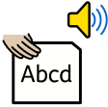 | 
  Autism | Makaton | Phonics (catch-up) | Team Teach
   |  |  | 
  Specific Learning Difficulties | Complex Needs training | Nurture support | Speech and Language
   |  |  | 
  De escalation | Attachment | Fluency | Sensory needs
  Transition Support | Pre-school to Reception  We hold a parent and carer session in the summer term for our new reception starters, providing parents with the opportunity to meet with the class teacher and SENDCO.  We hold ‘taster’ sessions for our new intake of children in the second half of the summer term in preparation for their August start.  The School SENDCo and EYFS Leader liaise with Pre-School provision to ensure a smooth transition for pupils with a special educational need, this could include visits to pre-schools and nurseries, meetings with staff, phone calls and email correspondence.  Transition to Reception, and then into each successive year-group, is supported by meetings, information leaflets for children and their families and taster sessions in each new class.  End of Year transition  When children move up a year, we provide transition booklets which include photos of the teacher, TA and classroom environment.  We hold a number of transition sessions during the summer term allowing the children to go up to their new classroom and meet their teacher.  Some children may require extra transition visits to their new classroom to help reduce their anxiety and ensure that the transition is successful and positive.  Class teachers and TAs meet with each other during the summer term to discuss the needs of the children and share Individual targets (Kinteract).  Secondary Transition  We liaise very closely with our partner schools to ensure that the transition from primary school to the secondary school is as smooth as possible. This includes:  Meetings with the KS3 SENDCOs  Children meeting key members of the KS3 staff within our school  Transition days as a cohort  Additional transition days in a quieter period of the KS3 timetable  Mid-Year new starters  When we are aware that pupils joining us from other settings have identified special educational needs, we arrange a meeting with the family to enable us to gain a greater understanding on the support we need to put in place before the child arrives. We communicate with the previous education setting and receive key documentation. We promote the whole family visit where possible.
  Outside Agencies | We work with the following agencies to provide support for children with SEND:  NHS School Nurse  NHS Speeach and Language  NHS Occupational Therapists  Visual Support Team  Specialist Teaching Services  Autism Outreach Team  Specialist Dyslexia Teacher  Mental Health Wellbeing Team  We will ask your permission before we arrange for any outside agencies to come in and work with your child. Once the feedback has been received, we will call you in for a meeting to share the advice.
  Clubs and Trips | All our extra-curricular activities and school visits are available to all our children, including our before-and after-school clubs.  All children are encouraged to go on our trips, including residentials.  All children are encouraged to take part in sports day, school competitions, school assemblies and performances, workshops, etc.  All children are encouraged to apply for roles of responsibility in school e.g. school council, house group leaders, ECO team, reading ambassadors.  No child is ever excluded from taking part in these activities because of their SEN or disability.  Please read the school’s accessibility plan for further information about the steps we have taken to prevent children with a disablitiy from being treated less favourably than other children and the arrangements we have made to help children with SEND access our school.
  Complaint Procedure | Your first point of contact is your child’s class teacher.  If you are not satisfied that your concern has been addressed, then you may make an appointment to speak to the SENDCO. If they cannot solve your issue, then an appointment can be made to speak to either of the Co-Headteachers.  If you are not happy with the response, then you may contact the governors through the school office.  Jenifer Smith – Chair of Governors  Hollie Roberts – SEND Governor
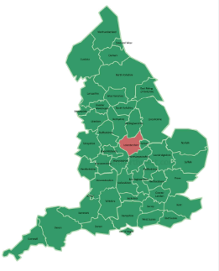  Leicestershire Local Offer | Parents can access information on the local offer for Leicestershire at https://www.leicestershire.gov.uk/education-and-children/special-educational-needs-and-disability
  Feedback | “We are pleased with how our child has settled into Y2 and the support put in place for her.”  “I would like to thank the teachers of Asfordby Hill Primary School for being so supportive and kind to our child and our family through a complex process of getting the support required for our child.”

