The Asfordby Hill School

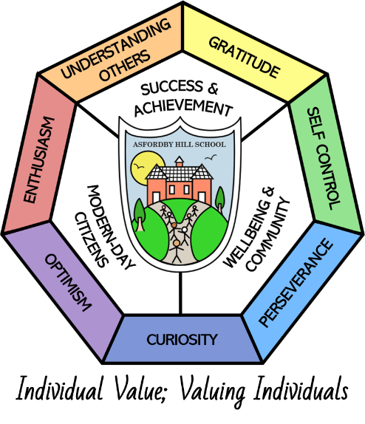

History POLICY

This Policy Links With:
Teaching and learning
Assessment
SEN Policy

Recommended: | Y
Statutory:

Date Reviewed: | January 2024
Date of Next Review: | January 2027
Committee Responsible for Review: | QEHS
Date agreed | 13.2.24

“We are not makers of history. We are made by history.”

Martin Luther King

Rationale

Asfordby Hill Primary School believes that History makes a valuable and distinctive
contribution to pupils’ education. Learning about the past and the methods used to study sources and draw conclusions helps pupils understand and contribute to the world in which they live.

Our school policy is developed in accordance with the National Curriculum for History and Foundation Stage Curriculum for talking about the lives of people around them and their roles in society; knowing some similarities and differences between things in the past and now, drawing on their experiences and what has been read in class; and understanding the past through settings, characters and events encountered in books read in class and storytelling. Throughout this policy, the term ‘History’ includes the Knowledge and Understanding elements of Foundation Stage Curriculum, alongside National Curriculum History for Key Stage 1 and 2.

Through history, pupils at Asfordby Hill Primary School will continue to deepen their understanding of the complexity of people’s lives, the process of change, the diversity of societies and relationships between different groups, as well as their own identity and the challenges of their time, through respect, care and appreciation for the others.

INTENT

To enable all children to:

- develop a sense of identity through learning about their family, the development of their community, Britain, Europe and the world.

- introduce children to what is involved in understanding and interpreting the past.

- develop a range of skills necessary for historical enquiry and interpretation.

- arouse an interest in the past and an appreciation of human achievement.

- understand the present in the light of the past; the influence that events in the past have in shaping the present.

- develop children’s knowledge and understanding of major issues and events in the history of their own country and others.

- acquire a chronological structure and language in order to provide a framework for understanding the past.

- understand the difference between the past and present and that people of other times and places may have held different values and attitudes from ours.
- enrich other areas of the curriculum.

The curriculum is designed to develop substantive skills and disciplinary skills that are progressive, as well as transferable, throughout their time at Asfordby Hill Primary and to their further education and beyond.

IMPLEMENTATION

- At Asfordby Hill we teach history in E.Y.F.S. as an integral part of the topic work covered during the year. We relate the historical aspects of the children’s lives now and then, making links and noticing changes which underpin the curriculum planning for children aged three to five. History makes a significant contribution to the objective in the ELGs of natural world; past and present; and people and communities.

- As the children move into Key Stage 1 they will build on their earlier work. Teaching and learning will focus on developing an awareness of the past, using common words and phrases relating to the passing of time. They will develop their knowledge of where the people and events they study fit within a chronological framework and identify similarities and differences between ways of life in different periods. They will use a wide vocabulary of everyday historical terms. They will ask and answer questions, choosing and using parts of stories and other sources to show that they know and understand key features of events. They will develop their understanding of some of the ways in which we find out about the past and identify different ways in which it is represented. They will learn about people, events and changes outlined in the long-term planning, and will be often introduced to historical periods that they will study more fully at key stages 2 and 3.
- At Key Stage 2 teaching and learning will be extended through a chronologically secure knowledge and understanding of British, local and world history, establishing clear narratives within and across the periods they study. They will note connections, contrasts and trends over time and develop the appropriate use of historical terms. They will regularly address and sometimes devise historically valid questions about change, cause, similarity and difference, and significance and will construct informed responses that involve thoughtful selection and organisation of relevant historical information. They will develop an understanding of how our knowledge of the past is constructed from a range of sources. They will learn about British, local and world history outlined in the long-term planning, and will have opportunities to focus on in-depth studies to help understand both the long arc of development and the complexity of specific aspects of the content.
- At all key stages, strong links will be made with other teaching areas of curriculum subjects, wherever possible.

- History will become a stimulus and a springboard for the development of oracy, writing and reading and for the development of thinking and reasoning skills.

- On every appropriate occasion, teachers will use first-hand experience, visits, visitors, artefacts and the local and wider environment to engage children’s interest and imagination.

History at Asfordby Hill is taught termly (one topic per term) throughout the year, so that children can achieve depth in their learning. Teachers have identified the key knowledge and skills of each blocked topic and consideration has been given to ensure progression across topics throughout each year group across the school. At the beginning of each topic, children are able to convey what they know already as well as what they would like to find out. This informs the programme of study and also ensures that lessons are relevant and take account of children’s different starting points. Consideration is given to how learners will be supported in line with the school’s commitment to inclusion.

Cross curricular outcomes in history are specifically planned for, with strong links between history and English lessons identified, planned for and utilised. The local area and community are fully utilised to achieve the desired outcomes.

Assessment

Assessments are used to inform teaching in a continuous cycle of planning. Short term assessments are made throughout each lesson to check pupils’ understanding, both substantive and disciplinary concepts through Assessment for learning (AfL), through strategies including retrieval practice and observations. These AfL outcomes are used to adjust future teaching and learning where necessary.

EYFS assessments are made through adult-led discussions and interactions against our curriculum ready to meet the end of year early learning goal expectations.

In KS1 and KS2, regular unit assessments are undertaken using our history curriculum assessment criteria for each individual unit. A child’s outcome will be emerging or expected. These judgements will be noted on the termly planning documents against the substantive and disciplinary concepts. This information is then used to make a final judgement on the whole year’s attainment.

Teaching history to children with special educational needs.

We teach history to all children, whatever their ability. History forms part of the school curriculum policy to provide a broad and balanced education for all children. We provide learning opportunities that are matched to the needs of children with learning difficulties. Our work in history considers the targets set in the children’s provision maps.

IMPACT

The teaching of history at Asfordby Hill will result in the majority of children not only acquiring the appropriate age-related substantive concepts linked to the history curriculum, but also the disciplinary concepts which will equip them to progress from their starting points to think like an historian, which will have impact within their everyday lives.

All children will have:

- A wider variety of disciplinary concepts linked to both historical substantive concepts and historical enquiry/investigative skills.
- A richer vocabulary which will enable children to articulate their understanding of taught concepts.
- High aspirations, which will see them through to further study, work and a successful adult life in modern day Britain.

