EYFS | 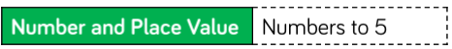  Baseline  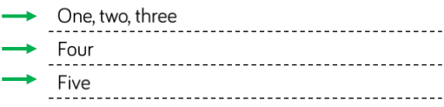  Patterns
Y1 | 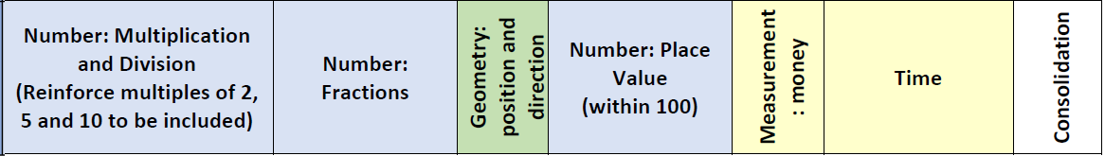
Y2 | 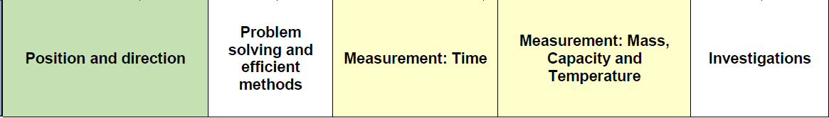
Y3 | 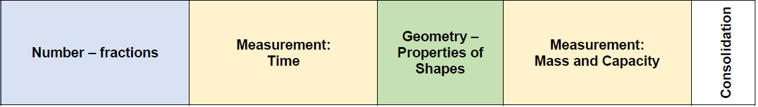
Y4 | 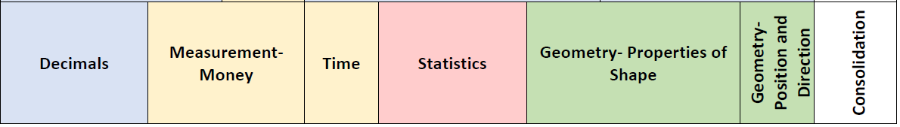
Y5 | 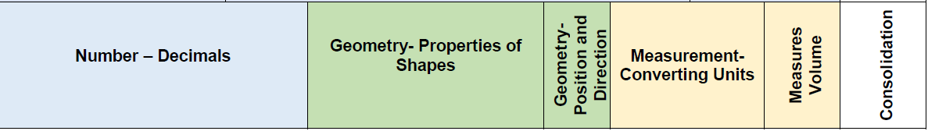
Y6 | 

