EYFS | 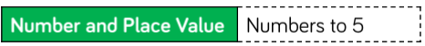  Baseline  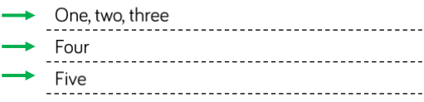  Patterns
Y1 | 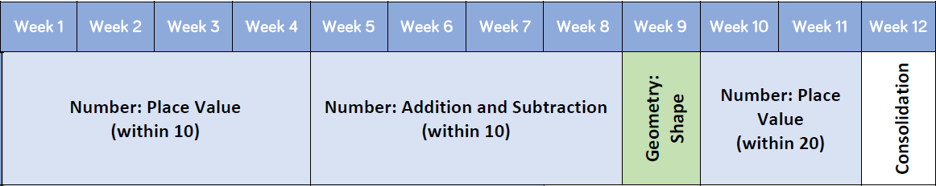
Y2 | 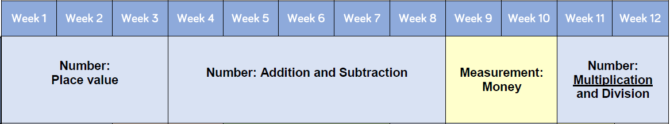
Y3 | 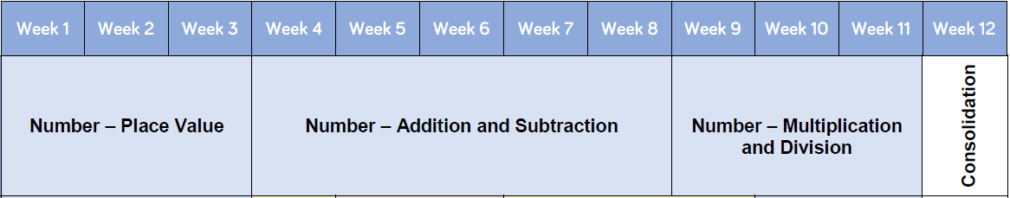
Y4 | 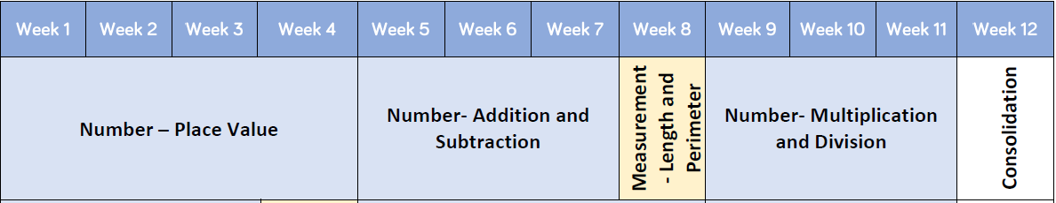
Y5 | 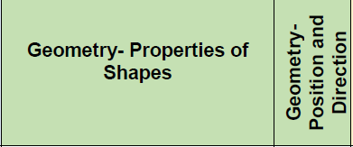  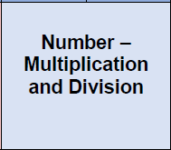  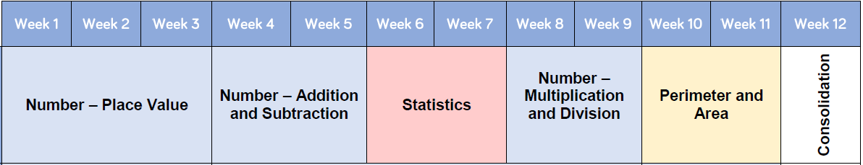
Y6 | 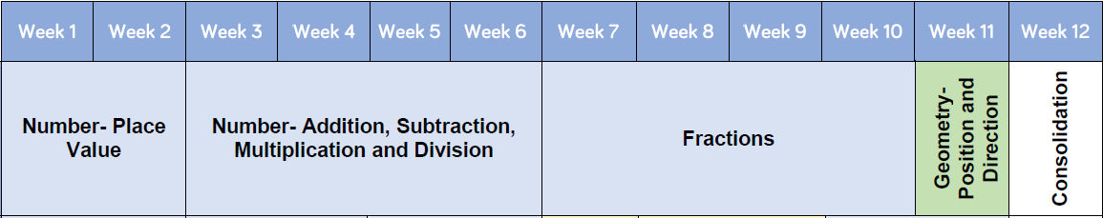

White Rose Scheme of Learning
https://whiterosemaths.com/resources/schemes-of-learning/primary-sols/

