Asfordby Hill School
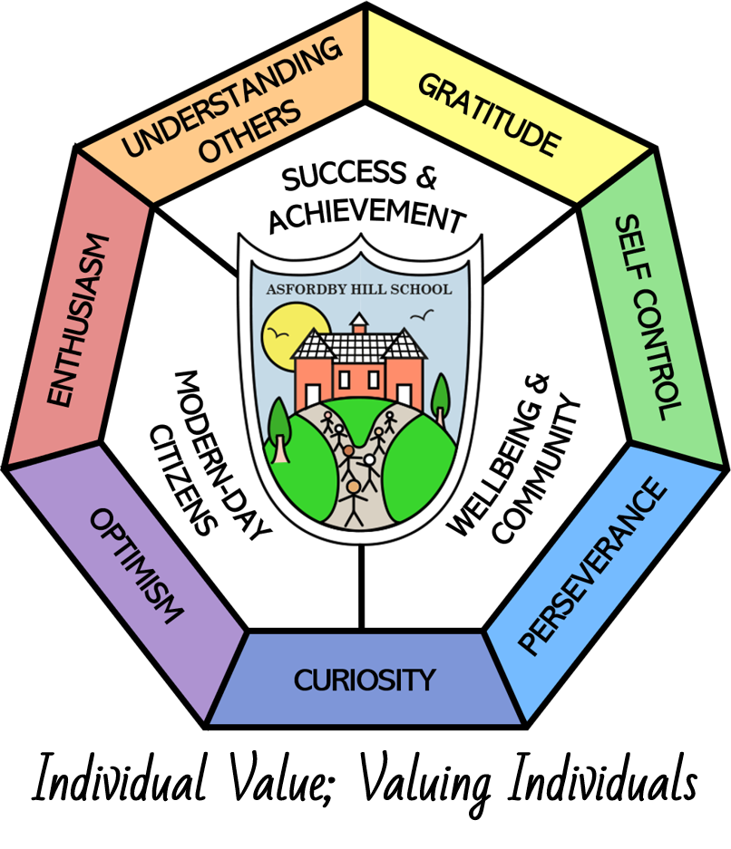

Recruitment and selection POLICY

This Policy Links With:
Safeguarding + KCSIE
Child protection
Equality
Recommended: | Y
Statutory:
Date Reviewed: | Autumn 2023
Date of Next Review: | Autumn 2026
Committee Responsible for Review: | FSAP
Signature of the Chair of Governors: | October 2023

Purpose

This policy has been designed to assist schools with the appointment of all vacant positions within their organisation. It should be noted that whilst there is separate recruitment guidance for Head Teacher/Principal posts, pre-employment checks for such posts remain the same as those required for teaching posts.

This document, and its associated guidance, will assist all those responsible for the recruitment process to ensure appropriate mechanisms for safer recruitment and selection are in place. This document also sets out best practice, taking in to account relevant legislation, the requirements of regulatory inspections (i.e., Ofsted) and the organisation’s commitment to Equality and Diversity.

For the purposes of this policy Schools and Academies will be referred to as “schools”, and Head Teacher/Principal will be referred to as “Head Teacher” throughout the document.

- Equal Opportunities

  - Everyone involved in recruitment and selection processes must be mindful of the Equality Act 2010 to ensure that anyone wishing to apply for a position at the school has an equal opportunity to do so.

  - Reasonable Adjustments
Reasonable adjustments must be put in place for any candidate who has identified that they have a disability and require adjustments to be made to enable them to fully participate in the process. The candidate should be consulted with well in advance of any adjustments required/ made, these may include (but are not limited to):

- ensuring the interviewing room has a wheelchair ramp;
- providing a skills test printed in large font;
- providing additional time to complete a test or prepare a presentation

1.3 Criminal Convictions
Having a criminal record does not automatically prevent a person from being employed within a school and applicants should not be treated unfairly if they have a previous conviction. Whilst a criminal record cannot be disregarded, the school must seek advice to ensure a fair and consistent approach when considering an applicant’s suitability for the role they are applying for.

- Personal Relationships

2.1 Where an employee who is involved in any part of the recruitment process has a personal relationship with an applicant, they should declare this from the outset. Such employees must then not be involved in:

- the recruitment processes;
- providing a reference or acting as a referee for that person where possible;
- making decisions relating to pay in respect of that individual;
- making decisions related to or the management of the employee’s performance;
- any conduct issues that arise that may involve the employee.

2.2 The recruitment panel should also check the application forms as candidates must also declare whether they have a personal relationship with any current members of staff.

- The Recruitment Process:

STEP 1: Review the Vacancy:

Recruitment takes place either as a result of an existing post becoming vacant or the creation of a new post owing to changing organisational needs. It is good practice to consider the following points:

- Is this a new post or an existing post?
- If an existing post, is this post still required?
- Can the school afford to recruit to the post within both current and future budgets?
- Are the working hours/times/grade of the post still appropriate?
- Is there an up-to-date Job Description and Person Specification (see below)?
- Is recruitment to a permanent/fixed term/full time/part time position?
- Do you require supply cover in place whilst recruiting to a permanent position?

For details of the different types of contracts available, see associated guidance document.

STEP 2: Prepare a Recruitment Plan

Ensure a realistic timetable is prepared for the recruitment process allowing sufficient time to:

- Agree a “Recruitment Panel”, usually comprising of three members. At least one panel member must have undertaken Safer Recruitment training.
- Create/review the job description & person specification to ensure they are both fit for purpose.
- If a new post, does this need to be evaluated to check the grade (for a non-teaching post).
- Prepare the job advertisement (part salaries should be clearly stated on the advert)
- Prepare any additional recruitment literature that will be sent out to applicants, i.e. the Job Pack
- Diary dates set aside for any potential informal visits to the school.
- Agree dates for:

- When the advert will be published and the duration of the advertising period;
- Closing date for the advert;
- Shortlisting meeting;
- Inviting candidates to interview;
- Applying for employment references;
- The selection/interview days i.e. venue, candidate activities, panel questions;
- Start date for successful applicant.

NB. All members of the panel should participate in every stage of the recruitment process.

STEP 3: Advertising the Job

When compiling the Job Advert, the following should be included:

  - A message about the culture of the school and the type of person needed for the role.
- Details of the key knowledge and skills required to undertake the role.
- A strap line outlining the school’s commitment to safeguarding and promoting the welfare of children and young people, for example:

“This school is committed to Safeguarding Children and Young People.”

- A statement that the post holder will be subject to a DBS Disclosure check, for example:

“As this post is required to work in ‘Regulated Activity’ an enhanced DBS with a Barred list check is essential”.

- A statement that shortlisted candidates will be subject to online searches (if applicable).

- For roles designated as “Regulated Activity” it is essential that the information sent to candidates makes it clear that references will be sought in advance of the interview.

- The closing date by which all completed applications should be sent to the school.

- The advert should be placed in such a way that the best range of prospective candidates can access it which best reflects the community that the school serves. Below are several options of where Schools can advertise their vacancy:

- School’s own website;
- Eteach/TES;
  - Local press;
- LCC Website – contact EMSS helpdesk for further details;
- Job Centre Plus – further information is available on the Job centre plus website;
- Social media.

- If advertising posts for overseas workers, additional rules apply in terms of the recruitment process and advertising the role. See associated guidance for more details.

STEP 4: Shortlisting

As soon as possible after the closing date, each member of the recruitment panel should receive a shortlisting pack (via the agreed method) which should include a copy of all the application forms (minus the equal opps form), a job description and personnel specification and the shortlisting grid in order to carry out the shortlisting exercise. All members of the panel should:

- Take part in the shortlisting process.
- Complete a separate shortlisting grid for each individual candidate. This promotes fairness and consistency whilst also providing an audit trail.
- Check for any gaps in employment history have a reasonable and acceptable explanation (see Safer Recruitment Requirements in the associated guidance document).
- Check that any additional information sent with the application is not considered as part of this process, unless this information was expressly requested by the recruitment panel, i.e a supporting letter outlining the individual’s suitability for the role.
- Ensure that all essential criteria (to be assessed by the application form) have been satisfied. Where this is not the case, the applicant may not be shortlisted.

Declaration of Criminal Conviction(s):
- Applicants will no longer be asked about any criminal record at the point of application (this section has been removed from the standard application form). This check must now be carried out once short-listing has taken place. A Criminal Records Self-Disclosure form will be sent to all shortlisted applicants along with the invite to interview letter to allow the disclosure of any relevant criminal convictions. Where an applicant declares they have a criminal conviction, they must provide the details on this Self-Disclosure form which should be placed in a sealed envelope. This envelope should remain with the Chair of the panel, un-opened until the end of the interview process.
- Following the interview, where the preferred candidate has declared a criminal conviction(s), the Chair will inform the panel. If the panel decide that the conviction(s) is relevant, further information should be sought from the candidate at the end of the interview and before an offer of employment is made. Where this form is received with an electronic signature, at the interview the shortlisted candidate will be asked to sign a hard copy of the form confirming the information they have provided is a true and accurate declaration.

On-Line Checks for Shortlisted Applicants:
- Consideration should be given to carrying out an online search as part of the due diligence on all shortlisted candidates. The purpose of this is to help identify any incidents or issues that have happened, the details of which are publicly available online.
- Such checks will be undertaken after shortlisting and by someone not involved in the recruitment process. Where issues are identified by this process details can be explored further with the applicant during their interview.
- All applicants must be made aware that such checks will be undertaken in order to “Determine their suitability to work with children and keep them safe” (e.g. by job advert and invite to interview letter).
- Caution should be taken when undertaking such checks. For further information on this, refer to the associated guidance document or seek advice from HR.

STEP 5: Invitation to Interview

Following the shortlisting meeting, arrangements should be made to write out to those individuals shortlisted inviting them for interview. This letter should detail the following:

- That the applicant has been selected to attend a recruitment process.
- The location, date and times of the interview.
- Outline the interview process, detailing any tests or assessments the candidates will be required to undertake.
- The requirement to bring relevant identification documentation to the interview day.
- The requirement to provide original documents verifying any qualifications essential for the job.
- The requirement to complete a Criminal Records Self-Disclosure form (this form should be sent with the invite letter).
- That, where necessary, on-line candidate search may be performed and the reasons for this.
- Details of who to contact should the applicant require any reasonable adjustments to allow them to attend and be able to fully participate in the interview process.

If a candidate advises that they are unable to attend for interview on the date specified, the panel has discretion to reschedule their interview date, however, the interview panel must remain the same.

STEP 6: Interview Preparation

It is essential for the recruitment panel to meet prior to the interviews to agree the format of the interview process. The panel must decide:

- What tasks or activities they will ask candidates to perform, i.e. in tray exercises, presentations or teaching a class.
- The questions to ask – all questions should be agreed in advance and should include a safeguarding question and a question on equal opportunities.
- Agreement should be made on how the panel will explore any gaps in employment history and any other concerns identified during shortlisting process.

It is important that methods used to test candidates are appropriate and proportionate to the duties of the role applied for and designed so that candidates are able to demonstrate their suitability for the role.

The chair of the panel is responsible for ensuring that arrangements are made for the smooth running of the interview process, including:

- All relevant documentation is prepared and distributed to panel members prior to interview.
- The suitability of the venue - taking into consideration any additional or special requirements such as access or any additional adjustments requested by the candidates.
- Any car parking spaces, refreshments etc. are arranged.
- Arranging the checking of the candidates identity documents.
- Arranging checking and copying of any additional documentation required at interview.
- Ensuring the interview timetable allows sufficient time between interviews for:

* Overruns; * Panel Discussion; * Breaks;

STEP 7: The Interview

The Chair of the panel is responsible for ensuring that the interview is conducted fairly and that all candidates are treated equally. The Chair should ensure that all panel members participate fully and the views of all panel members are considered at all stages.

Panel members must score each candidate independently and agree whole panel scores after each interview.

At the start of the interview, the Chair should:

- Welcome each candidate;
- Introduce the other panel members by name and job role;
- Give an overview of the interview process;
- Explain that notes will be taken during the interview by the panel members;

At the end of the interview, the Chair should:

- Give an opportunity for candidates to ask questions;
- Give an indication of timescales for decision and feedback;
- Ensure that all the relevant documents have been received and checked, e.g. evidence of qualifications.
- Ensure hard copies of any forms received electronically are signed by the candidate.
- Explore any issues raised by the Criminal Records Self Declaration form, and
- Explore any issues raised as a result of any on-line checks conducted on the candidate.

Step 8: Decision Making – Appointing the Preferred Candidate

All aspects of the selection process should be considered when making decisions to appoint a new employee, the successful candidate should have:

- Met all the essential criteria on the job description;
- The highest aggregated score, taking into account their scores for any additional tasks that they have been asked to complete as part of the selection process.
- There are satisfactory explanations for any previous criminal conviction or issues identified via the on-line searches.

It is also helpful for the panel to decide on a reserve candidate in case the first candidate declines the job offer.

Step 9: Informing the Successful Applicant

The chair of the panel should contact the successful candidate as soon as possible to advise them of their appointment.

A conditional offer should be made to the successful candidate. It should be explained that the post is not confirmed until all pre-employment checks are satisfactorily completed, these include:

- A check to ensure the candidate has the Right to Work in the UK;
- Proof of their identity (including full name, date of birth, address and photographic evidence of this). This should be a birth certificate and a valid passport;
- Confirmation of essential qualification and/or professional registrations.
- A satisfactory outcome of the medical questionnaire;
- A satisfactory DBS with a barred list check (where appropriate);
- Two satisfactory written references (one of which should be from the candidates’ current employer). Where an applicant is currently working in a position which does not bring them into direct contact with children, a further reference should be obtained from the most recent employer where the applicant last worked with children (if applicable).
- References should always be obtained and scrutinised and any concerns resolved satisfactorily before the appointment is confirmed.

It is good practice that all the other candidates be informed they have been unsuccessful and offered the opportunity to obtain feedback on their application or performance at interview. It is best practice to speak to unsuccessful applicants in person, usually via a phone call, but if the chair of the panel has been unable to reach a candidate, they should receive a written outcome stating that they have been unsuccessful.

- Recruitment Documentation Retention

4.1 Interview notes for all candidates (both successful and unsuccessful) must be retained for a period of 6 months, in case they are required in connection with an Employment Tribunal claim or have been requested by a candidate under the Data Protection Act. After this stage the documents for unsuccessful candidates must be destroyed.

- Pre-employment Checks

5.1 Pre-employment checks are an essential aspect of the recruitment process and should be conducted on both newly appointed employees and internal candidates (including those who have TUPE transferred into the organisation) prior to commencement in post. All checks undertaken must be accurately recorded on the Safer Recruitment Checklist.

5.2 In addition, and importantly, details of all checks undertaken should also be recorded on the School’s Single Central Record.

5.3 For agency and third party supply staff, schools must also include on their single central record that written confirmation has been received from the agency/business supplying the individual that they have carried out relevant checks, obtained the appropriate certificates, the dates that confirmation was received and whether any enhanced DBS certificate check has been provided in respect of the individual.

- Single Central Record

6.1 Schools must keep a single central record of all employment checks carried out. A template SCR can be found on LTS On-Line.

6.2 The single central record must cover the following people:

- All staff (including supply staff) who work at the school;
- All other staff who work in regular contact with children in school or college, including volunteers;
- For independent schools, including academies and free school, all members of the proprietor body.

6.3 Multi Academy Trusts (MATs) must maintain the Single Central Record detailing checks carried out in each academy within the MAT. Whilst there is no requirement for the MAT to maintain an individual record for each academy, the information should be recorded in a way that allows for the details of each individual academy to be provided separately to those entitled to inspect the information.

6.4 Ofsted will check the School’s single central record during their inspection visits with the expectation that it will meet at least the statutory requirements.

- Transfer of undertakings (Protection of Employment) (TUPE)

7.1 Employees who are TUPE transferred into the school, or from a school to academy or from an academy to Multi Academy Trust, must have their documentation checked within 60 days of the transfer. Head teachers should follow the required checking process set out in the associated guidance.

7.2 Schools should be aware that sponsor licenses are non-transferable from one employer to another under TUPE Regulations. In such circumstances the school must make an application for either a sponsor license or to extend the existing sponsor license. An application must be made with 20 working days of the move taking place.

7.3 If the school does not make a valid application to become a sponsor within 20 working days or does make an application, but this is refused, all of the migrants who have transferred, except those that can be sponsored under any existing licences, will have their leave, or worker authorisation shortened to 60 calendar days.

