Asfordby Hill Primary School

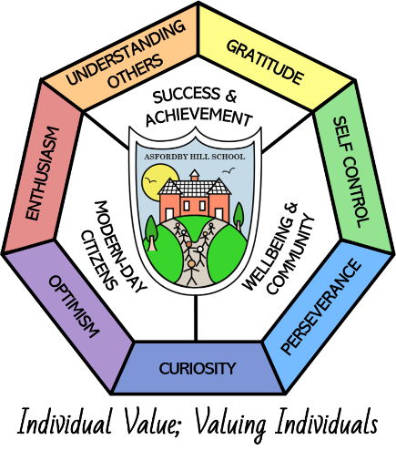

Britishness Statement

This Statement Links With:
Equality of Opportunity Policy
Teaching and Learning Policy
SEN policy
Trips and Visits Policy
Curriculum Provision Planning Documents (see website)
Recommended: | Yes
Statutory:

Date Reviewed: | November 2024
Date of Next Review: | November 2027
Committee Responsible for Review: | QEHS
Date Governors agreed | 11.11.24

Britishness at Asfordby Hill Primary School

Introduction
As of September 2014, the DfE requires all schools to promote the historical and current values that underpin the national identity known as “being British”. Within this, all schools are required to ensure that the curriculum actively promotes these fundamental British values.

What is “Britishness”? British values are defined as:

- Respect for democracy and support for participation in the democratic process
- Respect for the basis on which the law is made and applies in England
- Individual liberty - the support and respect for the liberties of all within the law
- Respect for and tolerance of different faiths and religious and other beliefs

What does ‘Actively promote …’ mean?
- Focus on, and show how, the school’s work is effective in securing these values
- Challenging pupils and young people, staff or mums, dads or carers who express opinions contrary to British values

Aims
At Asfordby Hill Primary School – and in line with the individual pupils’ capacity to understand the concepts and ideas – we aim to:

1. Democracy:
- Provide pupils with a broad general knowledge of, and promote respect for, public institutions and services
- Teach pupils how they can influence decision-making through the democratic process
- Include in the curriculum information on the advantages and disadvantages of democracy and how it works in Britain
- Encourage pupils to become involved in decision-making processes and ensure they are listened to in school
- Help pupils learn how to argue and defend points of view
- Help pupils to express their views
- Teach pupils how public services operate and how they are held to account
- Model how perceived injustice can be peacefully challenged

2. Rule of law
- Ensure school rules and expectations are clear and fair
- Help pupils to distinguish right from wrong
- Help pupils to respect the law and the basis on which it is made
- Help pupils to understand that living under the rule of law protects individuals
- Include visits from the police in the curriculum
- Teach pupils aspects of both civil and criminal law and discuss how this might differ from some religious laws
- Develop restorative justice approaches to resolve conflicts

3. Individual liberty
- Support pupils to develop their self-knowledge, self-esteem and self-confidence
- Encourage pupils to take responsibility for their behaviour, as well as knowing their rights
- Model freedom of speech through pupil participation, while ensuring protection of vulnerable pupils and promoting critical analysis of evidence
- Challenge stereotypes
- Implement a strong anti-bullying culture
- Pupils, parents and staffs views are valued and sought, all pupils are made aware, where possible of others needs and how to support each other.

4. Respect and tolerance
- Promote respect for individual differences
- Help pupils to acquire an understanding of, and respect for, their own and other cultures and ways of life
- Challenge prejudicial or discriminatory behaviour
- Organise visits to places of worship
- Develop links with faith communities
- Develop critical personal thinking skills
- Discuss differences between people, such as differences of faith, ethnicity, disability, gender or sexuality and differences of family situations, such as looked-after children or young carers
- Pupils are encouraged to celebrate diversity, recognise their own and others strengths, encounter, celebrate and appreciate difference

Teaching and Learning

Every school is expected to ensure that its curriculum enables the pupils to explore what it means to be British.
Asfordby Hill Primary School intends:
- To enable pupils to develop their self-knowledge, self-esteem and self-confidence;
- To enable pupils to distinguish right from wrong and to respect the civil and criminal law of Britain;
- To encourage pupils to accept responsibility for their behaviour, show initiative, and to understand how they can contribute positively to the lives of those living and working in the locality of the school and to society more widely;
- To enable pupils to acquire a broad general knowledge of and respect for public institutions and services in Britain;
- To further tolerance and harmony between different cultural traditions by enabling pupils to acquire an appreciation of and respect for their own and other cultures;
- To encourage respect for other people;
- To encourage respect for democracy and support for participation in the democratic processes, including respect for the basis on which the law is made and applied in Britain
- To enable pupils to describe their own identities and the groups that they feel they belong to;
- To support pupils to appreciate that identity consists of many factors;
- To enable pupils to recognise that each person’s identity is unique and can change;
- To enable pupils to begin to understand the idea of stereotypes.

