The Asfordby Hill School

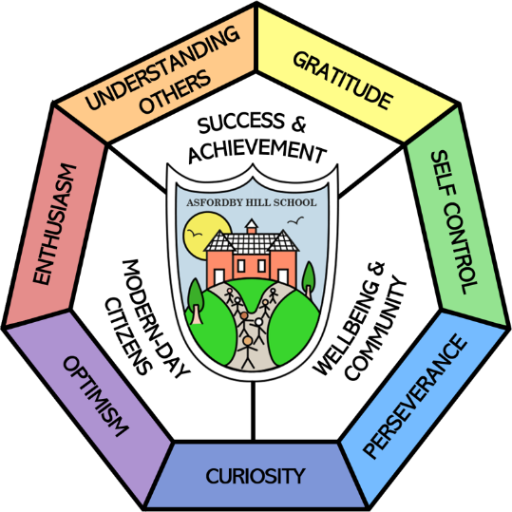
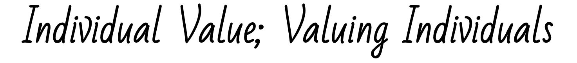

Our Vision & Aims:
Success & Achievement | Modern-Day Citizens | Wellbeing & Community
- All children have their personal success celebrated.  - All children achieve highly, regardless of background.  - All children are resilient, respectful and confident learners. | - All children leave with deep, flexible knowledge.  - All children leave literate, including digital literacy.  - All children experience a rich, broad and balanced curriculum built on foundational British values. | - All children are happy and safe at school.  - All children equipped to take charge of their own wellbeing.  - All children experience an excellent personal development program.

Modern Foreign Languages POLICY

This Policy Links With:
Teaching and learning
SEN Policy Assessment
Recommended: | Y
Statutory:
Date Reviewed: | November 2024
Date of Next Review: | November 2027
Committee Responsible for Review: | QEHS
Date Governors agreed | 11.11.24

"If you talk to a man in a language he understands, that goes to his head. If you talk to him in his own language, that goes to his heart."
Nelson Mandela

- Curriculum Intent
At Asfordby Hill Primary School, we value Modern Foreign Languages (MFL) as an important part of the children’s entitlement to a broad and balanced curriculum. We believe that learning a Modern Foreign Language is a liberation from insularity and provides an opening to other cultures along with deepening an understanding of the world.
We follow the National Curriculum for MFL and aim to ensure that all pupils:
• understand and respond to spoken and written language from a variety of authentic sources
• speak with increasing confidence, fluency and spontaneity, finding ways of communicating what they want to say, including through discussion and asking questions, and continually improving the accuracy of their pronunciation and intonation
• can write at varying length, for different purposes and audiences, using the variety of grammatical structures that they have learnt
• discover and develop an appreciation of a range of writing in the language studied
- Curriculum Implementation
Our teaching of French begins in Key Stage 2 although younger children do hear simple phrases and words throughout their learning. Children in Key Stage 2 are taught through French topics for eg ‘On Mange’. It is also integrated into our classroom day by encouraging the children to use French in their daily routines e.g. answering the register in French, greeting each other in French or by following simple instructions in French. Details of the curriculum plan can be found in our Curriculum section of the school website. In Appendix 1 you can see the vocabulary used in each year. These documents are comprehensive and shows clear progression through each year group and give opportunities for children to revisit vocabulary and use it in different contexts.
- Curriculum Impact
We want children to enjoy learning languages and be able to communicate for practical purposes and in a meaningful context. We aim to enable children to express their ideas and thoughts in another language and to understand and respond to its speakers, both in speech and in writing. We hope that learning a language will lay the foundation for learning further languages, equipping pupils to study, travel and work in other countries.
- MFL for pupils with SEND
All children with SEND have the opportunity to learn French through differentiated and adapted tasks.

- Assessment
Ongoing assessments take place throughout the year. Teachers and children feedback against the learning objective or the term’s learning. Teachers use this information to inform future lessons; ensuring children are supported and challenged appropriately. Each year ends with a task for children to complete which is assessed and passed on to the next year group. Age related expectation levels are reported to Key Stage 2 parents at the end of the year in the school report.
- Resources
At Asfordby Hill Primary School we use the Rigolo scheme of work. In addition we have story books and games in French.
- Monitoring and review
The monitoring of the standards of children’s work and of the quality of teaching in MFL is the responsibility of the MFL subject leader. There will be an opportunity each year for the subject leader to lead a professional development meeting for the teaching staff to ensure skills and progression are always enhanced and subject knowledge is strong.

Appendix 1: Modern Foreign Languages – French Rigolo: Skills/Knowledge progression
Year 3 | Year 4
Understand, say, read and write a few familiar spoken words and phrases  - The teacher’s instructions  - A few words and phrases in a song or a rhyme  - Numbers from 1 – 10  - Hello and goodbye  - What is your name?  - My name is …  - I am … years old  - Classroom objects  - Colours  - Parts of the body  - Days of the week  - Introduce themselves | Understand, say, read and write a range of familiar spoken phrases  - Animals and pets  - Numbers from 1 – 31  - Give someone’s name  - Describe someone  - Family members  - Use the letters of the alphabet  - Household items and position of them  - Identify and ask for snacks  - Simple opinions (about snacks)  - Months of the year  - Form dates  - Where is France?  - Animal fact card
Bonjour, salut, au revoir,  Comment tu t’appelles? Je m’appelle … Ca va Ca va mal  un, deux, trois, quatre, cinq, six, sept, huit, neuf, dix  J’ai ,,, ans  table, stylo, crayon, regle, gomme, cahier, sac, trousse, j’ai un/e …. téte, nez, yeux, bouche, les orielles, les cheveux, jambe, bras  rouge, bleu, vert, marron, jaune  lundi, mardi, mercredi, jeudi, vendredi, Samedi, Dimanche  je suis … grand, timide, jollie, petit, drôle, sympa bavard | Chien, lapin, tortue,oiseau, souris, dragon, cheval  Onze, douze Treize, quatorze, quinze, seize, dix-sept, dix-huit, dix-neuf, vingt vingt et un trente  Il/elle s’appelle …  Il/elle est … féroce travaille dur/polie/fort/mignon il/elle a … ans  Pomme,banana,jus d’orange, sandwich, une pizza, un gâteau, c’est délicieux, j’aime/je n’aime pas c’est bon/ c’est mauvais  Janvier, février, mars, avril, mai, juin, juillet, avril, mai, août, septembre, octobre, novembre, décembre  Maman, père soeur frère mes parents mon/ma/mes  Le lectuer de l’ordinateur la chaise, un lit

Year 5 | Year 6
Understand, say, read and write the main points in a passage made up of familiar language in simple sentences.  - Descriptions of people: nationality, physicality, family, character  - Talk about activities  - Use the time  - Talk about festivals and dates  - Numbers 1- 60  - Use instructions  - Research famous French cities  - Character description | Understand, say, read and write familiar sentences.  - Numbers 1-100  - Going to French cities  - Basic directions  - The weather  - Food shopping  - Opinions (about food)  - Party activities  - Positive and negative phrases  - Identify and use items of clothing  - Role play a day out
Longs/courts bouclés sportif sévère drôle (il a les cheveux longs et bruns)  Français, canadien/ne, suisse, britannique  Je regarde, j’écoute, je joue … la tele/au football, mes CD, au tennis  Il est …. heures je regarde le tennis a cinq heures  Le Nouvel an, la Saint-Valentin, Pâques, la Fête Nationale, Noél  Je voudrais … un vélo, un livre, un jeu, un oeuf Pâques,  très/un peu  etre avoir | Où vas-tu Où est …. Je vais à l’école/Paris/Nice/Notre Dame/Bordeaux  Tournez à driote, à gauche, allez tout droite, arrêtez  Quel temps fait-il? Il fait beau/Il fait froid/Il pleut/Il neige  à Pais il neige aujourd hui  Qu’est-ce que tu veux? Je voudrais… du pain/du fromage, de la lemonade, de la crème, des tomates, des fraises etc  On boit, On s’amuse, on chante, on danse, on mange  C’est chouette, bizarre, nul, amuse,  Je ne … pas (vais, ai, mange, aime, veux, parle) il/elle n’a pas pantalon, veste, chemise, jupe, un chapuau  Je parle Je ne parle pas anglaise/français

Classroom instructions used through the years: regardez, écoutez, lisez, asseyez-vous, levez-vous, écrivez, chantez, répétez, comptez, tournez, sautez

