Asfordby Hill School
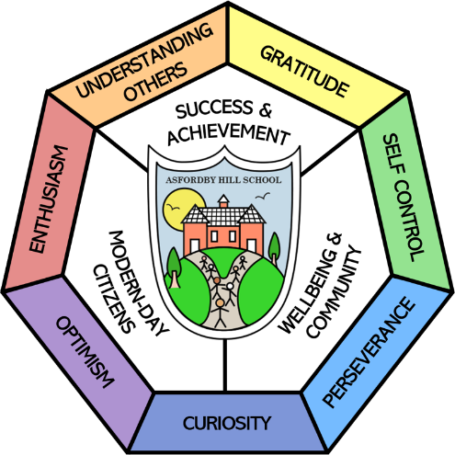

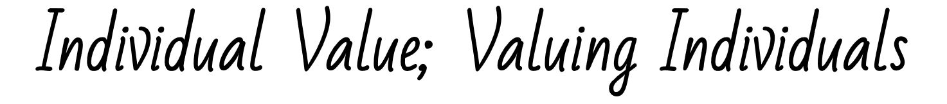

Our Vision & Aims:
Success & Achievement | Modern-Day Citizens | Wellbeing & Community
- All children have their personal success celebrated.  - All children achieve highly, regardless of background.  - All children are resilient, respectful and confident learners. | - All children leave with deep, flexible knowledge.  - All children leave literate, including digital literacy.  - All children experience a rich, broad and balanced curriculum built on foundational British values. | - All children are happy and safe at school.  - All children equipped to take charge of their own wellbeing.  - All children experience an excellent personal development program.

Music POLICY

This Policy Links With:
Teaching and learning Policy
SEN Policy
Recommended: | Y
Statutory:
Date Reviewed: | November 2024
Date of Next Review: | November 2027
Committee Responsible for Review: | QEHS
Agreed on: | 11.11.24

“Music education opens doors that help children pass from school into the world around them – a world of work, culture, intellectual activity and human involvement.”
President Gerald Ford

Rationale
Music is a universal language that embodies one of the highest forms of creativity. A high quality music education should engage and inspire pupils to develop a love of music and their talent as musicians, and so increase their self-confidence, creativity and sense of achievement. As pupils progress, they should develop a critical engagement with music, allowing them to compose, and to listen with discrimination to the best in the global musical repertoire.

Intent
At Asfordby Hill Primary School we aim to ensure that all pupils:
- perform, listen to, review and evaluate music across a range of historical periods, genres, styles and traditions, including the works of the great composers and musicians
- learn to sing and to use their voices, to create and compose music on their own and with others, have the opportunity to learn a musical instrument, use technology appropriately and have the opportunity to progress to the next level of musical excellence
- understand and explore how music is created, produced and communicated, including through the inter-related dimensions: pitch, duration, dynamics, tempo, timbre, texture, structure and appropriate musical notations.

Implementation
At Asfordby Hill Primary School we predominantly use the ‘Charanga Music School’ scheme of work which supports all of the requirements of the National Curriculum and gives children access to a wide range of musical concepts and experiences. Skills and concepts are built upon through a ½ term Unit of Work. The ‘Charanga Musical School’ Scheme provides teachers with week-by-week lesson support for each year group in the school. It is ideal for specialist and non-specialist teachers and provides lesson plans, assessment, clear progression, and engaging and exciting whiteboard resources to support every lesson.
The learning within this scheme is based on: Listening and Appraising; Musical Activities - creating and exploring; and Singing and Performing.
There are opportunities for teachers to move away from Charanga, for example to teach Upper KS1 children the recorder and teach the music dimensions through activities with Boomwackers. We also give Upper KS 2 children a unit of work focusing on composing on i-pads, using the programme ‘Garage Band’.
Music lessons are delivered by class teachers or music specialists. The school uses a variety of teaching and learning styles in lessons including modelling, demonstrating and exploration. Children also have the opportunity to use/listen to a wide range of instruments.
In Year 5 and 6 all children are given the opportunity to learn to play the Ukulele and in Year2,3 and 4 children learn to play the recorder. All instruments are provided by the school.
All children are also given the opportunity to extend their skills further on an individual or small group basis in lessons delivered by peripatetic teachers and paid for by parents, or by the school for disadvantaged pupils.
Finally whole school assemblies offer our children opportunities to listen to music by a variety of composers, from different cultures, learning together not only about context, structure and instrumentation but also developing an appreciation and awe and wonder of the pieces played. One assembly a week is dedicated to fun whole school singing: performing together helps to forge the community feel that Asfordby Hill Primary School is renowned for.

Cross Curricular Links
The teaching of Music enhances other curriculum areas. It is the class teachers’ responsibility to bridge other areas of the curriculum to Music, broadening the pupil’s experiences.

Extra-Curricular Music
The school provides a number of opportunities for children to take part in extra-curricular music including choir and recorder club.

Differentiation
The Programme of Study for each Key Stage should be taught to pupils in ways appropriate to their abilities. Children with exceptional musical skills will be identified at an early stage and parents offered support to receive appropriate peripatetic teaching and signposted to out of school opportunities to perform with others.

Assessment for learning
Children demonstrate their ability in music in a variety of different ways. Teachers will assess children’s work in music by making informal judgements as they observe them during lessons. This may look like
- Questioning in order to gauge children's musical understanding, ie open-ended questioning and using the outcomes to guide formative assessment.
- Share what has taken place during the lesson and work towards performing to an audience.

EYFS
Music plays an important part in a child’s early development. The Early Years Foundation Stage Curriculum encompasses all areas of creative development, particularly in the area of Expressive Arts and Design. Charanga provides specific support in introducing the dimensions of music to our youngest children, in a practical, fun and active way.

Equal Opportunities
The music policy firmly supports the equal opportunities philosophy of the school. Every child, regardless of gender, ethnicity or ability is given equal access to all aspects of the music curriculum and participates fully in all music lessons. There is a commitment to value, explore and perform music of all cultures as music plays an important part in the celebration of religious and cultural festivals.

Resources
The school has a number of tuned and untuned percussion instruments including glockenspiels, guitars, ukuleles, violins, clarinets, chime bars, drums, tambourines, wood blocks, cymbals, triangles, beaters of various sizes, a piano, as well as computers/tablets. Children use these instruments to explore, learn about and organise the different musical dimensions.

Impact
Key stage 1
At the end of KS 1, most children will be able to:
- use their voices expressively and creatively by singing songs and speaking chants and rhymes
- play tuned and untuned instruments with musicality
- listen with concentration and understanding to a range of high-quality live and recorded music
- experiment with, create, select and combine sounds using the inter-related dimensions of music.

Key stage 2
At the end of KS 2, most children will be able to:
- play and perform in solo and ensemble contexts, using their voices and playing musical instruments with increasing accuracy, fluency, control and expression
- improvise and compose music for a range of purposes using the inter-related dimensions of music
- listen with attention to detail and recall sounds with increasing aural memory
- use and understand staff and other musical notations
- appreciate and understand a wide range of high-quality live and recorded music drawn from different traditions and from great composers and musicians
- develop an understanding of the history of music.

Performance opportunities
Apart from opportunities to record their work and perform for other classes across the school, other opportunities include Class assemblies, Christmas performances and an KS1/KS2 and EYFS productions. We also like to take part in community events, working alongside other schools to produce a performance.

Responsibility
The subject leader for Music is responsible for:
- Providing leadership and vision
- Updating the music policy
- Carrying out the requirements of the school improvement plan linked to music.
- Monitoring the delivery and impact of the published scheme of work and advising on actions needed
- Identifying and implementing appropriate staff training
- Supporting colleagues in their planning and implementation of the scheme of work and in assessment the progress of their children against the age-related expectations.
- Planning, providing and maintaining resources.

