The Asfordby Hill School

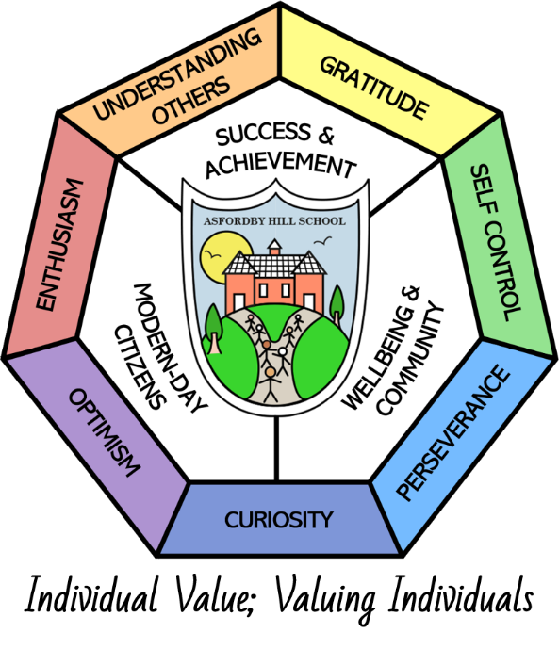

Pupil Premium POLICY

This Policy Links With:
Teaching and Learning
Equality
SEN
Trips and Visits
Complaints Procedure
Recommended: | Yes
Statutory:

Date Reviewed: | Autumn 2024
Date of Next Review: | Autumn 2026
Committee Responsible for Review: | QEHS
Date policy agreed

The capacity to solve life's problems is based on our abilities to learn to think above and not below the problems.
Auliq Ice

Pupil Premium funding is allocated by the DFE to pupils who are known to have been eligible for free school meals (FSM) at any time during the last 6 years (EVER 6). Each of these pupils attracts additional funding. Schools have the freedom to spend the Premium, which is in addition to the school budget, in a way they think will best support the raising of attainment for the most vulnerable groups of pupils, being advised to follow the Government Guidelines.

Principles
- We ensure that teaching and learning opportunities meet the needs of the pupils.
- We ensure that the appropriate provision is made available for pupils who belong to vulnerable groups, this includes ensuring that the needs of socially disadvantaged pupils are adequately assessed and addressed.
- In making provision for socially disadvantaged pupils, we recognise that not all free school meals pupils will be socially disadvantaged.
- We also recognise that not all pupils who are socially disadvantaged are registered for free school meals. We reserve the right to allocate the Pupil Premium funding to include additional pupils, within a focus group of children.
- Pupil Premium funding will be allocated following a needs analysis, which will identify priority classes, groups or individuals. Limited funding and resources may mean that not all pupils receiving free school meals will be in receipt of Pupil Premium interventions at specific times.

Provision
The range of provision offered by the school to Pupil Premium pupils could include:

- Smaller class sizes
- Small group work with an experienced teacher focussing on overcoming gaps in learning and providing quality feedback
- 1:1 support
- Additional teaching and learning opportunities provided by external agencies in order to widen and enhance learning experiences
- Financial support for clubs, resources, visits
- Specific therapy relevant to the pupils needs
- Resources to aid the learning of socially disadvantaged children
- Professional development to provide high quality first teaching
- All work will be aimed at accelerating progress and moving children to reach at least age related expectations

Reporting
It is the responsibility of the head teacher to:

- Track the progress made towards narrowing the gap for socially disadvantaged pupils
- Assess the impact of support through data analysis
- Evaluate the cost effectiveness, in terms of progress, made by the pupils receiving a particular provision
- Produce an annual report on how Pupil Premium funding is spent and the impact on the spending, along with a plan on how the grant will be spent (using advice for EEF)

The governors will ensure that there is an annual statement to parents on how pupil premium is spent and this will appear on the school’s website.

Appeal
Any appeal against the policy will be heard through the governing body complaints procedure.

