Asfordby Hill Primary School
Science Policy
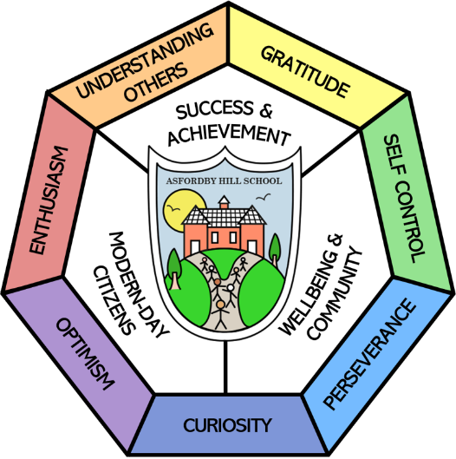
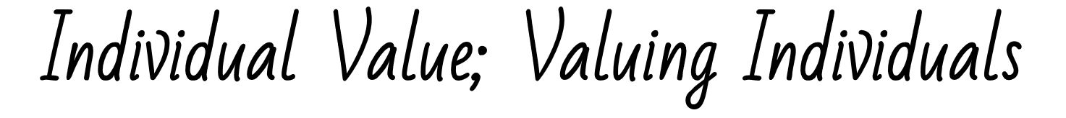

Our Vision & Aims:
Success & Achievement | Modern-Day Citizens | Wellbeing & Community
- All children have their personal success celebrated.  - All children achieve highly, regardless of background.  - All children are resilient, respectful and confident learners. | - All children leave with deep, flexible knowledge.  - All children leave literate, including digital literacy.  - All children experience a rich, broad and balanced curriculum built on foundational British values. | - All children are happy and safe at school.  - All children equipped to take charge of their own wellbeing.  - All children experience an excellent personal development program.

This policy should be read in conjunction with the following policies:
Teaching and learning Policy Assessment Policy
SEN Policy Health and Safety Policy
Recommended or Statutory
Date Reviewed: July 2024 | Date of Next Review: July 2027
Committee Responsible for Review: |  | QEHS
Signature of the Chair of Governors:
“What you do makes a difference, and you have to decide what kind of difference you want to make.” – Jane Goodall.

Vision
At Asfordby Hill Primary School, our vision for science is that all pupils develop a secure foundation in the knowledge and skills they will need for the future, both for their time in secondary school and post-16 study and in their lives beyond education. Pupils will have hopefully developed a passion for science.

Rationale
This policy is developed in accordance with the National Curriculum Science Programme of Study, as well as the Early Years Foundation Stage (EYFS) Early Learning Goals (ELG). It aims to create consistency in science across the school by outlining our intended curriculum, along with how teachers will implement this curriculum, consisting of key research-informed assessment practices and pedagogical choices. It is these three components – curriculum, assessment and pedagogy – which blend to create impact in science at Asfordby Hill Primary School.

Intent
The curriculum was redesigned and redeveloped in 2021 and has been monitored developed and iterated year upon year to ensure a knowledge-rich yet developmentally appropriate, progressive, coherent curriculum which fits into Asfordby Hill Primary School’s wider 3D curriculum. The curriculum has been sequenced carefully within and across year groups to allow for new knowledge to be systematically integrated into pupils’ pre-existing knowledge, creating the opportunity for new knowledge to become part of pupils’ emerging conceptual structures, with important scientific concepts being revisited and built upon over time.
The science curriculum aims to enable all children to:
- develop children’s substantive knowledge, building their understanding of wider scientific concepts (such as life processes, light and states of matter) through the specific disciplines of biology, chemistry and physics;
- develop children’s understanding of the nature, processes and methods of science (working scientifically) through development of the 7 scientific enquiry skills, as noted by the Primary Science Teaching Trust (PSTT), which are: predicting, asking questions, planning and setting up enquiries, observing and measuring, recording data, interpreting and reporting, and evaluating enquiries;
- expose children to the wide range of science-related careers and represent the diversity of people who are scientists or are in science-related jobs, ensuring all children ‘see someone like them’ in science, in the effort to improve aspiration for typically underrepresented groups i.e. girls and ethnic minorities;
- foster and continue to sustain children’s curiosity, awe and wonder about the rapidly changing world around them, whilst equipping them with the knowledge and skills to understand it; and
- empower children to make informed choices in relation to their own wellbeing and the wellbeing of the environment.

Implementation – Pedagogy
In EYFS, children develop their scientific knowledge, skills and vocabulary through focused activities as well as opportunities through continuous provision and enhanced provision. Science learning in EYFS is often seen through the ‘understanding the world’ aspect of the EYFS curriculum.
From year 1-6, science is taught in discrete lessons, for a minimum of 1 hour (but recommended for 1½ - 2 hours) each week.
- Curriculum sequencing: The curriculum at AHS is carefully sequenced within and across year groups. Complex concepts, procedures and ideas are broken down into meaningful ‘chunks’ of learning, which have been carefully sequenced across year groups, allowing children to build knowledge without working memory being overloaded. Within each year group from year 1-6, units have a recommended sequence. However, teachers may use (where appropriate) their professional judgement and understanding of their own classes to adapt the order in which this content is presented to children (including objectives within topics) to match their needs.
- Elicitation of prior knowledge: Teachers understand that children are not ‘blank slates’; they bring their own experiences and ideas to the classroom. All teachers plan activities to elicit children’s prior knowledge at the beginning of a learning sequence. This allows teachers to check children are ‘ready’ for new learning: that they possess the relevant prior knowledge needed to understand new content and to gauge children’s current ideas about an upcoming topic. They uncover children’s misconceptions and identify children who are likely to struggle with new learning due to gaps in prior knowledge.
- Activation of prior knowledge: Where appropriate, teachers activate children’s prior knowledge at the beginning of lessons. This increases the chances of children successfully connecting and embedding new learning into their schema. They understand that connecting new learning with prior knowledge reduces their intrinsic cognitive load. Keeping intrinsic load to a manageable amount allows for encoding of learning from working to long-term memory.
- Retrieval practice: Teachers embed retrieval practice in a variety of ways within the classroom to ensure that previously learnt material is not forgotten. They understand that ‘using our memory, shapes our memory’. Retrieval practice content varies from recently taught material to material which was first learnt at the beginning of the children’s science journey. Teachers allow content to be slightly ‘forgotten’ before retrieval so that the retention and recall of that content becomes stronger. Strategies may include low-stakes quizzing, brain dumps, flash cards and others.
- Outdoor learning: Teachers may use the outdoors to enhance science learning where appropriate. Research suggests the following as benefits of outdoor learning: multi-sensory learning enhances encoding from working to long-term memory; higher levels of engagement as learning is related to a real-life context; and outdoor environments often act as rich stimulus for creative thinking. Teachers may use the on-site sensory garden, pond area/eco garden or forest area, or may utlilise off-site grounds when planning for outdoor learning. Activities may include: pond dipping, sound/sensory trails, nature observations, gardening, and many others.
- Vocabulary: Teachers expose all children from EYFS to Y6 to a wide range of scientific vocabulary. In KS1, teachers do this mainly orally, often through shared reading of stories, picture books, non-fiction texts, rhymes and poems. Their meanings are then explicitly taught alongside visual stimuli (to aid encoding from working memory to long-term memory) and related to an appropriate context. This continues within KS2, where children read increasingly challenging scientific vocabulary within scientific texts. Meanings are explicitly taught to children and links to morphology and etymology may be made. Teachers maintain high expectations by encouraging children to use this challenging vocabulary orally and in written work.
- Models and analogies: Teachers use models and analogies to explain the many abstract concepts in the primary science curriculum. By using effective models and analogies, new concepts are related to prior knowledge, increasing the likelihood that information moves from working memory to long-term memory. Teachers may use models for different purposes: to provide a solid foundation for understanding; after formative assessment to tackle misconceptions; or to allow for elaboration — where children can apply their scientific knowledge to the model themselves, deepening their understanding. Teachers explicitly discuss the parallels of the analogy or model to the features of the abstract idea and use this to explain further features/aspects of the idea. Teachers may also combine multiple models of the same concept, comparing their similarities, to further aid understanding.
- Purposeful enquiry: Teachers understand that enquiry forms an important part of science education, and it must have a clear purpose: to aid conceptual understanding or teach disciplinary knowledge/enquiry skills. Teachers consider the aims of enquiry approaches carefully when planning lessons. If the purpose is to teach an enquiry skill whilst also teaching substantive content, this is likely to overload children’s working memory, impeding their ability to achieve either objective. So, if the purpose of enquiry is to teach disciplinary knowledge, then the scientific context should be something children already are familiar with and have knowledge of. When enquiries are performed by children, this may be led by the children or (more often than not) guided by the teacher. Practical work may also take the form of teacher demonstrations.

Implementation - Assessment

Assessments are used to inform teaching in a continuous cycle of planning. Informal assessments are made throughout each lesson to check pupils’ understanding of both substantive and disciplinary knowledge through assessment for learning (AfL) through strategies including quizzing, exit tickets, hinge questions and observations. This information is then used to adjust future teaching and learning where necessary to ensure that children make expected progress.

EYFS assessments are made through adult-led discussions, observations and interactions against our curriculum ready to meet the end of year ELGs. In year 1-6, teachers provide a summative assessment judgement at the end of the year as to whether children are working towards or at age-related expectations for science, informed by school assessment guidance. Additionally, at the end of key stage 2 (KS2), statutory judgements as to whether children are working towards or at age-related expectations are submitted to the DfE, informed by the Teacher Assessment Framework issued by the STA. As of 2023/24, it is no longer statutory for end of key stage 1 judgements to be reported to the DfE.

Special Educational Needs (SEN)/Adaptive Teaching
Science is taught to all children, regardless of SEN. Science forms part of the school curriculum policy to provide a broad and balanced education for all children. We adapt learning opportunities to ensure that all children, including those with SEN, can access learning in science and/or are provided with learning opportunities that match their needs where severe learning difficulties mean that they would struggle to access the same objectives as their peers as per provision maps.

Essential Health and Safety Information
It is important that all teachers are aware of the responsibility they have regarding health and safety both inside and outside the classroom. Teachers need to take account of both the children’s and their own health and safety when involved in science activities. Risk assessments are the responsibility of the class teacher and will follow the school’s risk assessment policy. Teachers should consult the science lead and/head teacher if unsure regarding risk assessments.
When working with tools, equipment and materials, pupils will be taught:
- about hazards, risks and risk control;
- to recognise hazards, assess consequent risks and take steps to control the risks themselves and with others;
- to use information to assess the immediate and cumulative risks to themselves and others;
- to manage the environment to ensure the health and safety of themselves and others; and
- to explain the steps they take to control risks.

Impact
Impact is monitoring through a triangulation process, where at least two (or more) of the following may be used:
- ’book looks’ are conducted with children (and teachers where possible);
- child interviews are conducted to understand what knowledge has been retained and attitudes towards science;
- learning walks are conducted by the subject leader and/or SLT with specific foci in mind that has been shared with staff; and
- data/trend analysis of end of year teacher assessment data is carried out by the subject leader.
We will know that provision in science is effective if:
- 80% or more of children meet the TAF substantive knowledge statements at the end of KS1 and KS2.
- Children can confidently retrieve substantive knowledge from a variety of science topics throughout their time at AHS.
- 80% or more of children meet the TAF working scientifically statements at the end of KS1 and KS2.
- Children can begin to understand the scientific method and can ask scientific questions and find out answers using scientific enquiry by the end of KS2
- Children can talk about how science is used in the real world, name a variety of diverse scientists (modern and historical) and can identify a variety of different science-related careers.
Some children may also aspire to work in some of these jobs.
- Children ask questions such as ‘what if…’ and ‘why…’ about the world around them.
- Children have positive experiences of learning in science.
- Children show empathy and care for the natural world and strategies on how to care for it.
- Children can talk confidently about the importance of and how they can manage their physical and mental health.

